SIMULATIONS OF THE LINAC4 - PSB INJECTION IN THE PRESENCE OF SPACE CHARGE

Issues and progress

E. Benedetto, V. Forte, M. Martini
3 May 2013
20 TURNS INJECTED BEAM WITH SPACE CHARGE WITH 1% PARTICLES “ARTIFICIALLY” REMOVED (2424 out of 250000) OUTSIDE THE RF BUCKET (STANDARD PIPE+ QH=4.28 & QV=4.55)
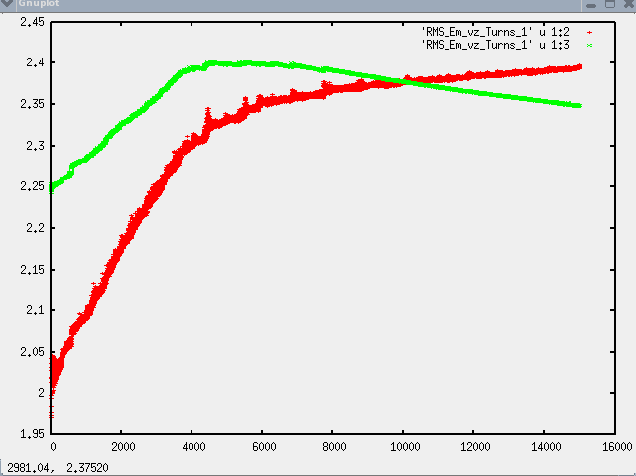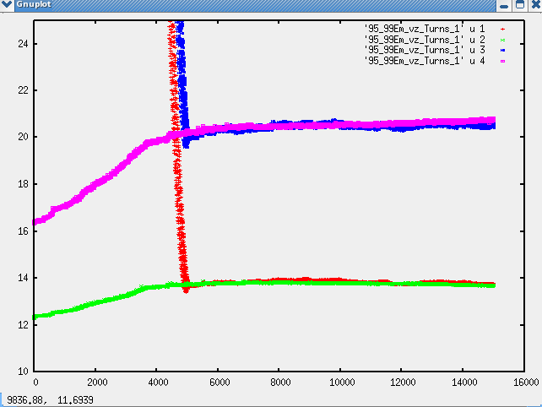
H & V physical 99% emittances
tracking
H & V physical 95% emittances
tracking
H & V physical RMS emittances
tracking
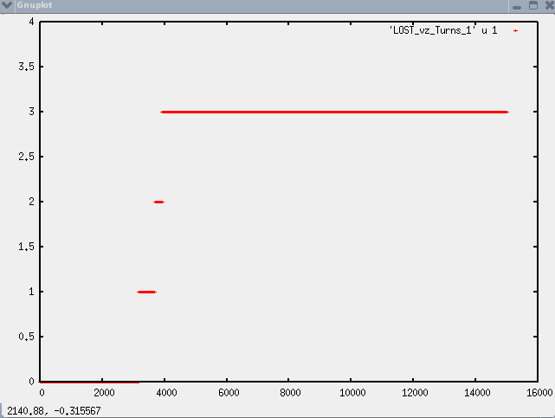
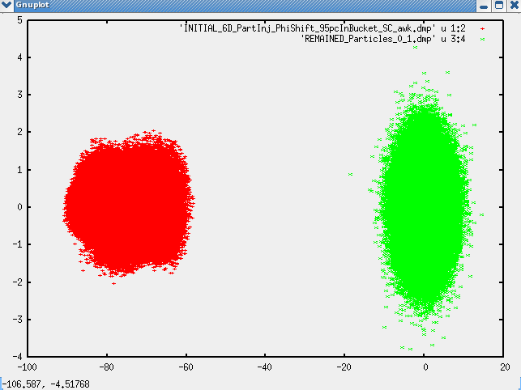
PARTICLES LOSSES VS TURNS
3 macro-particles lost on Beamscope aperture out of 247576
H phase space after 20 injected turns with space charge
H phase space after 15021 tracking turns with space charge
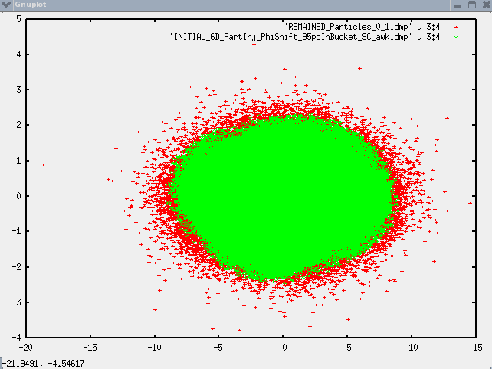
H phase space after 20 injected turns with space charge
tracking
V phase space after 15021 tracking turns with space charge
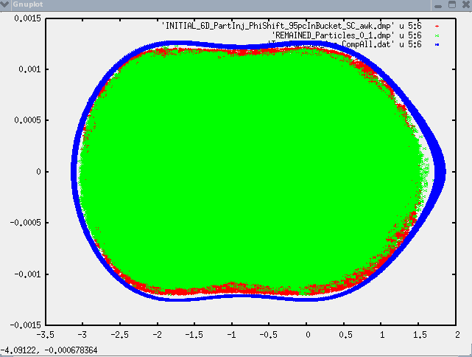
RF bucket from 160 MeV injection to 170.6 MeV at turn 7000
L phase space after 20 injected turns with space charge
tracking
L phase space after 15021 tracking turns with space charge
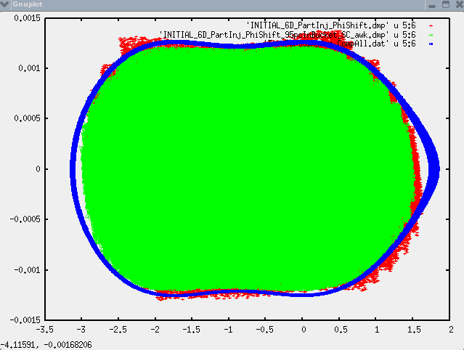
RF bucket evolution from 160 MeV injection to 170.6 MeV after 7000 tracking turns

tracking
L phase space after 20 injected turns with space charge and with particles outside the bucket removed
tracking
L phase space after 20 injected turns without space charge and without particles removed

18 April 2013
20 TURNS INJECTED BEAM WITHOUT SPACE CHARGE WITHOUT PARTICLES REMOVED OUTSIDE THE RF BUCKET (STANDARD & INCONEL PIPES + QH=4.28 & QV=4.45/4.55)
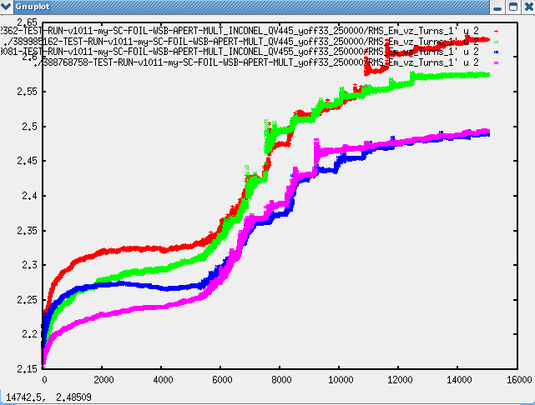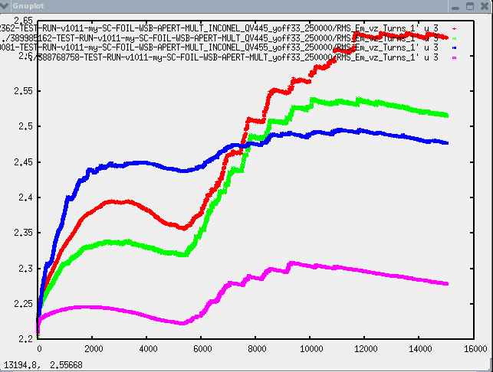
STD & QV=4.45
tracking
INC & QV=4.45
tracking
INC & QV=4.55
tracking
STD & QV=4.55
tracking
V physical RMS emittances

tracking
INC & QV=4.45
tracking
STD & QV=4.45
tracking
INC & QV=4.55
tracking
STD & QV=4.55
tracking
H physical RMS emittances

tracking
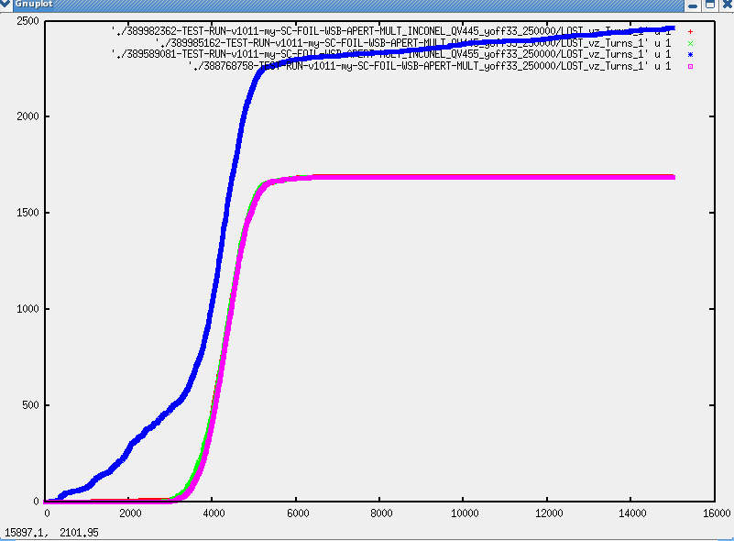
INC & QV=4.45
tracking
INC & QV=4.55
tracking
STD & QV=4.45
tracking
STD & QV=4.55
tracking
~1700 particles lost on Beamscope aperture out of 250000
PARTICLES LOSSES ON APERTURE (Beamscope) VS TURNS

INCONEL PIPE + QH=4.28 & QV=4.55 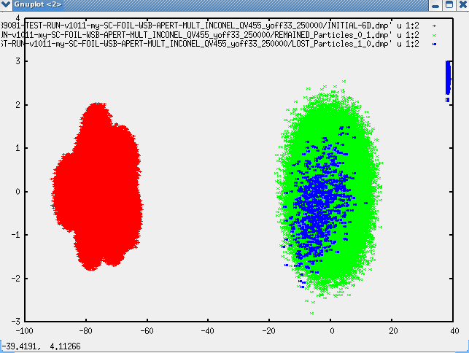
H phase space after 20 injected turns without space charge
INC & QV=4.55
tracking
H phase space after 15000 tracking turns with space charge
Particles lost on aperture
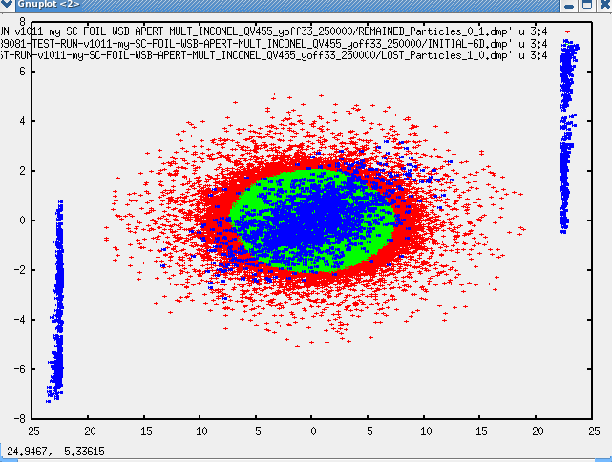
V phase space after 20 injected turns without space charge
V phase space after 15000 tracking turns with space charge
Particles lost on aperture
INC & QV=4.55
tracking
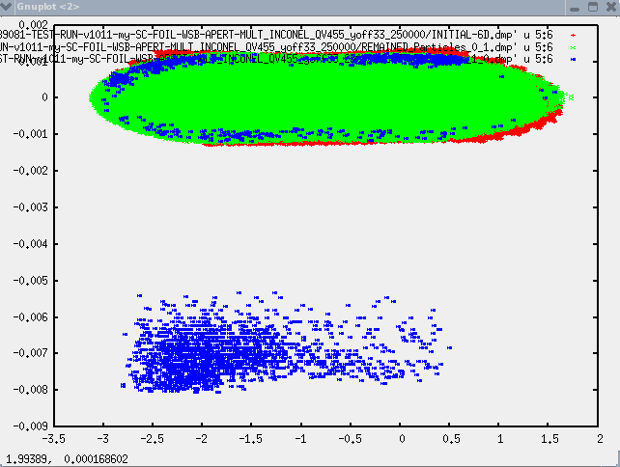
L phase space after 20 injected turns without space charge
L phase space after 15000 tracking turns with space charge
Particles lost on aperture
INC & QV=4.55
tracking

STANDARD PIPE + QH=4.28 & QV=4.55
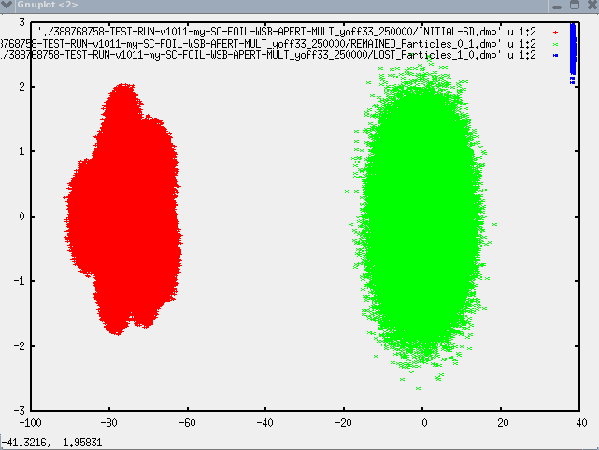
H phase space after 20 injected turns without space charge
STD & QV=4.55
tracking
H phase space after 15000 tracking turns with space charge
Particles lost on aperture st
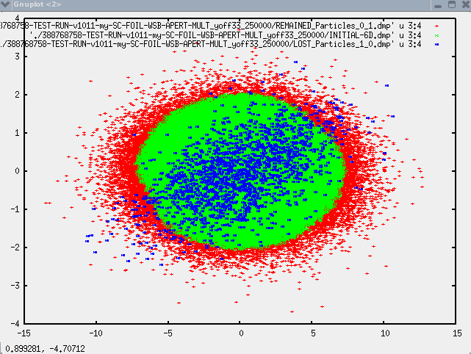
V phase space after 20 injected turns without space charge
V phase space after 15000 tracking turns with space charge
Particles lost on aperture
STD & QV=4.55
tracking
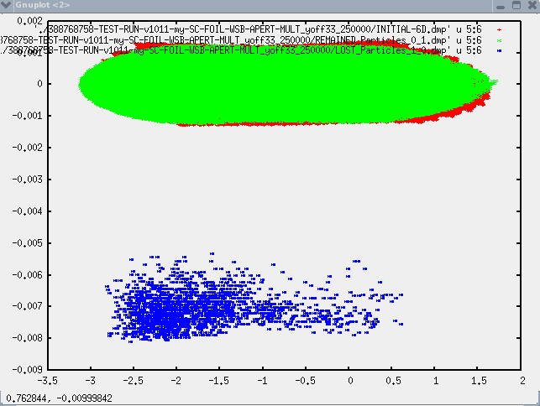
L phase space after 20 injected turns without space charge
L phase space after 15000 tracking turns with space charge
Particles lost on aperture
STD & QV=4.55
tracking

